2- TestRail

Test Plans in TestRail:

Go to Test Runs & Results and click on Add Test Plan:
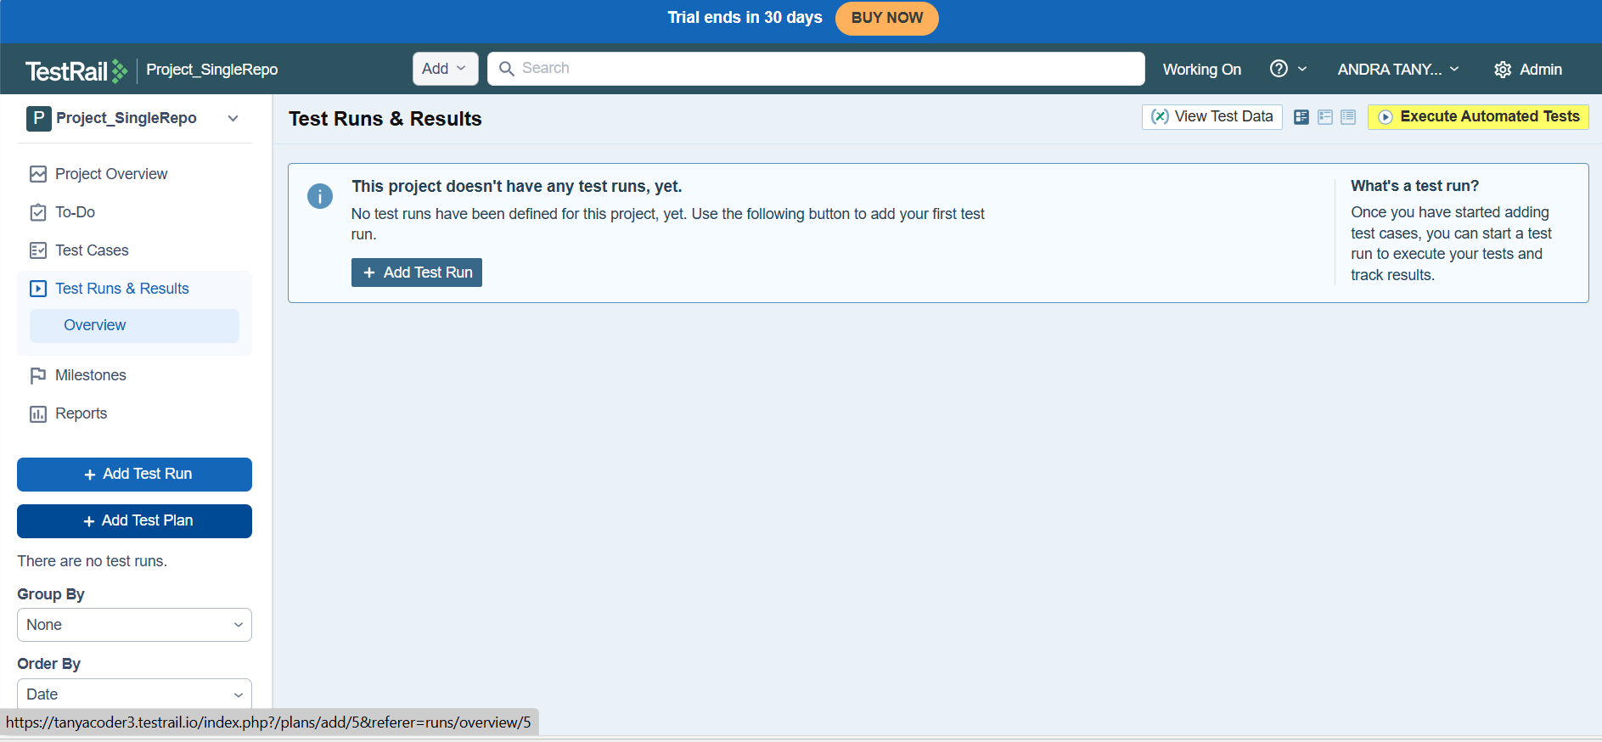

Click on Add test run after entering details of Test Plan:
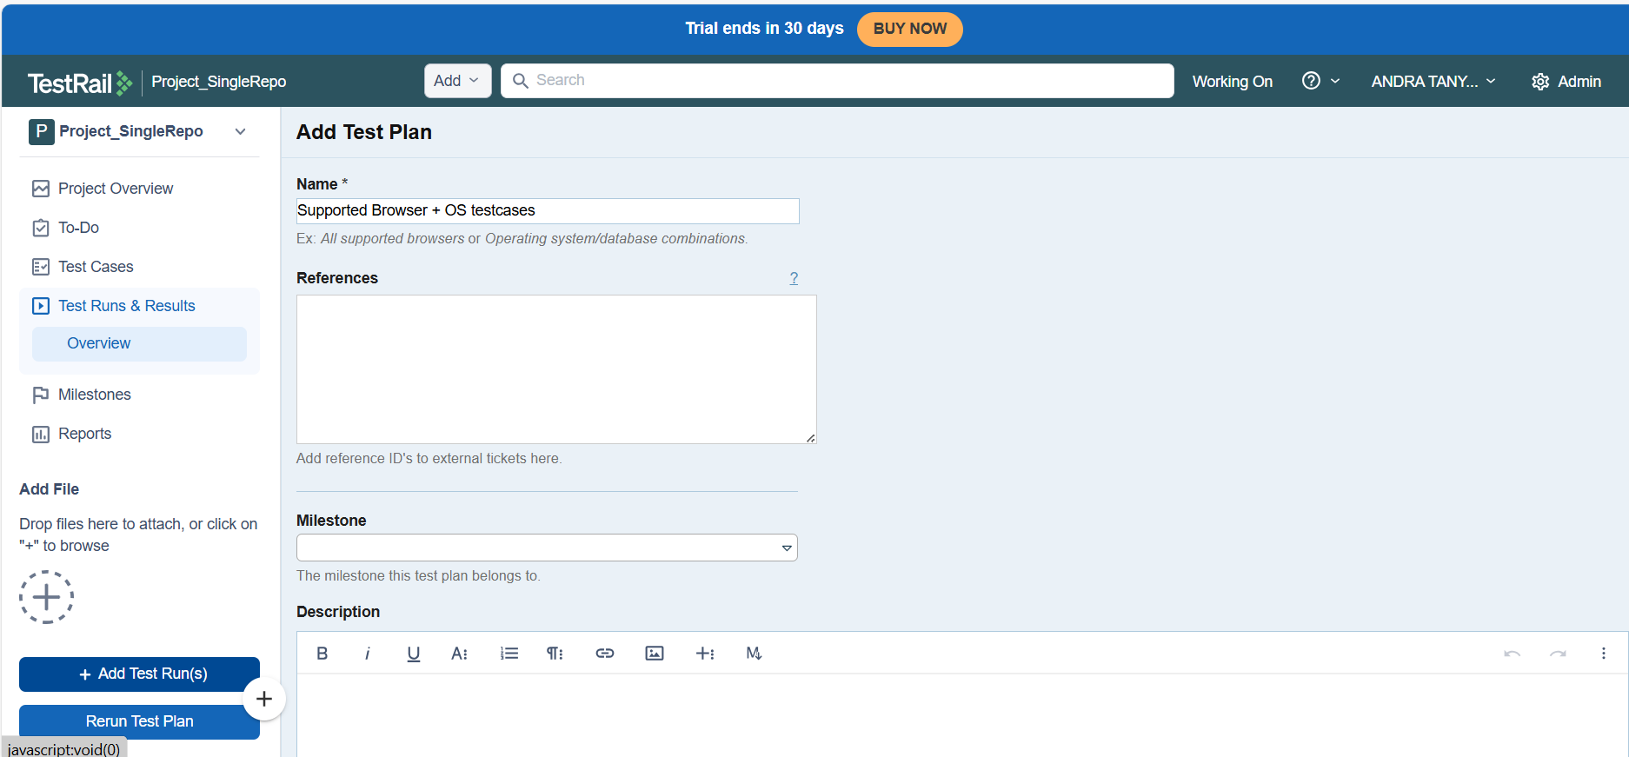

You will get to see Test Run and its details along with configurations too so that you edit those things:
Simply click on Configurations to add group of configurations and select them for the planned Test Run
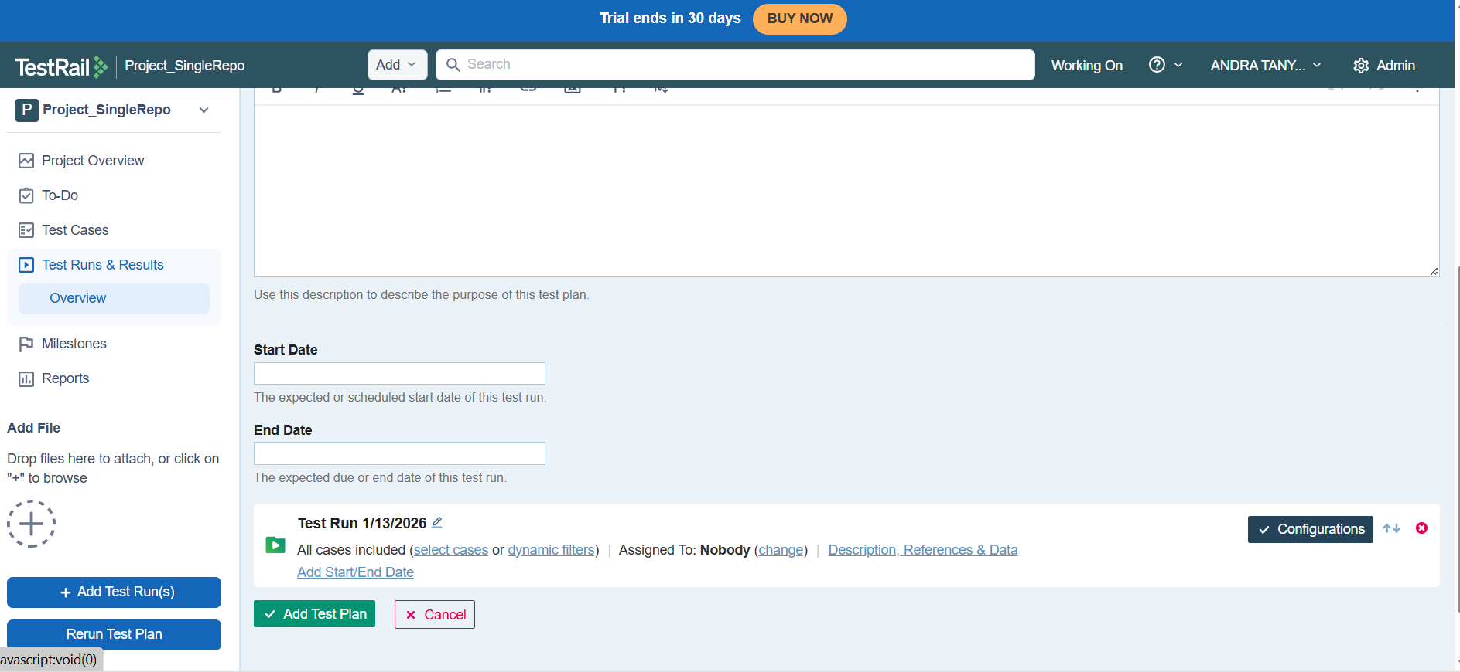

Add group and then add configuration as many as you want:
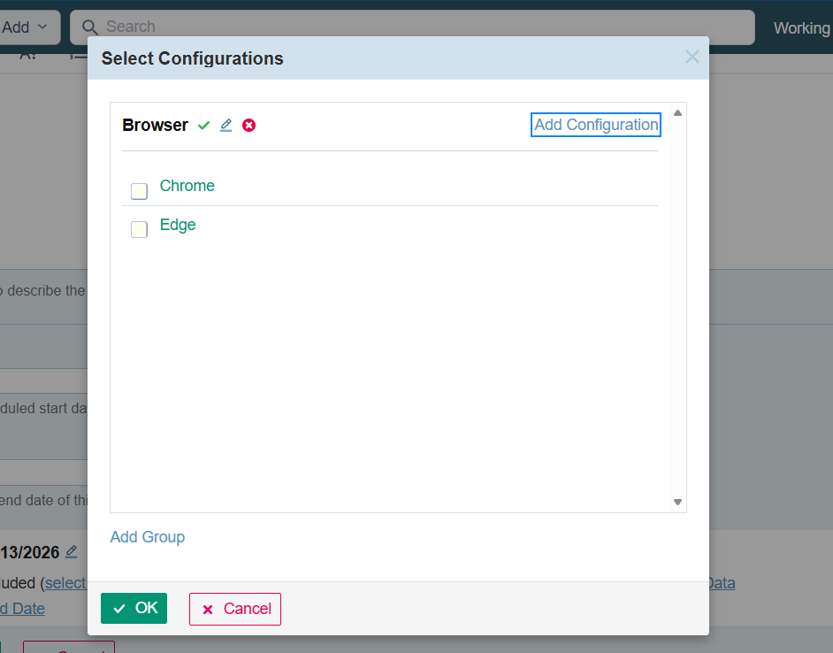

After selecting the needed configurations, click on Ok

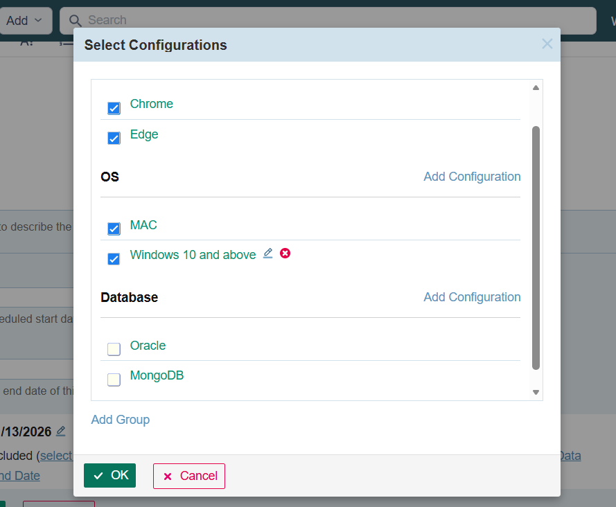

Go ahead and choose the specific cases on which the this test run is planned to execute upon and to whom this is assigned to etc.,

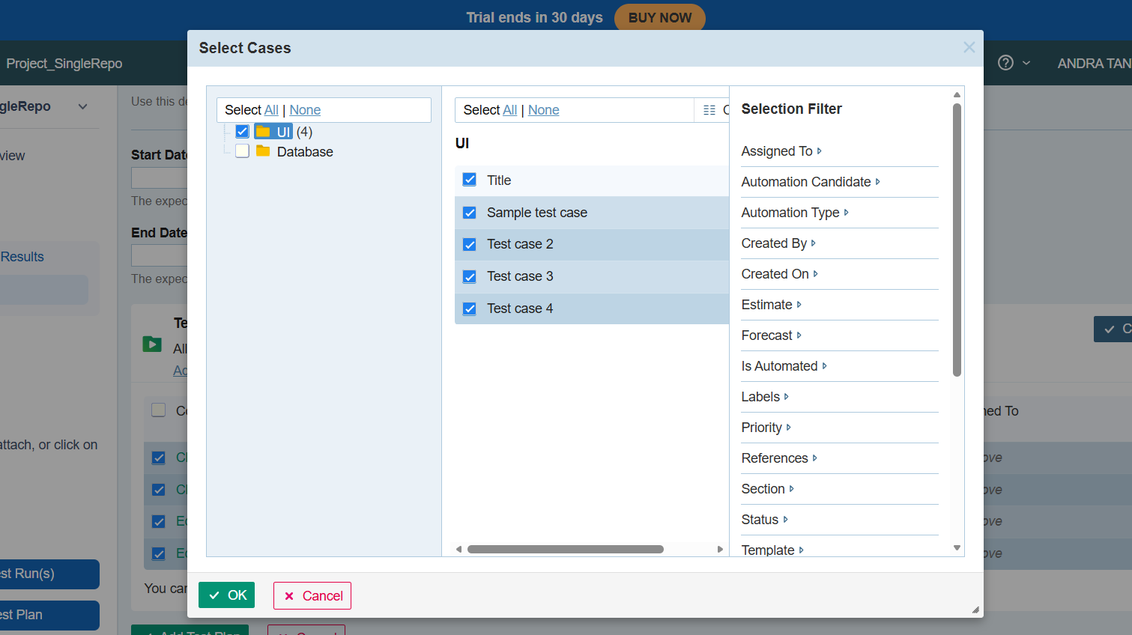

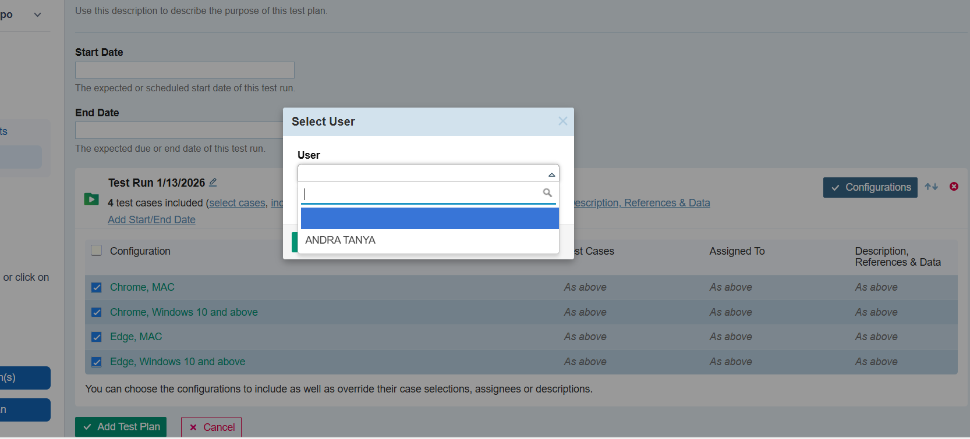

Finally after all the configurations, simply click on Add Test Plan
You can see the complete details of the Test Plan regarding its all Test Runs in the Tests & Results page:

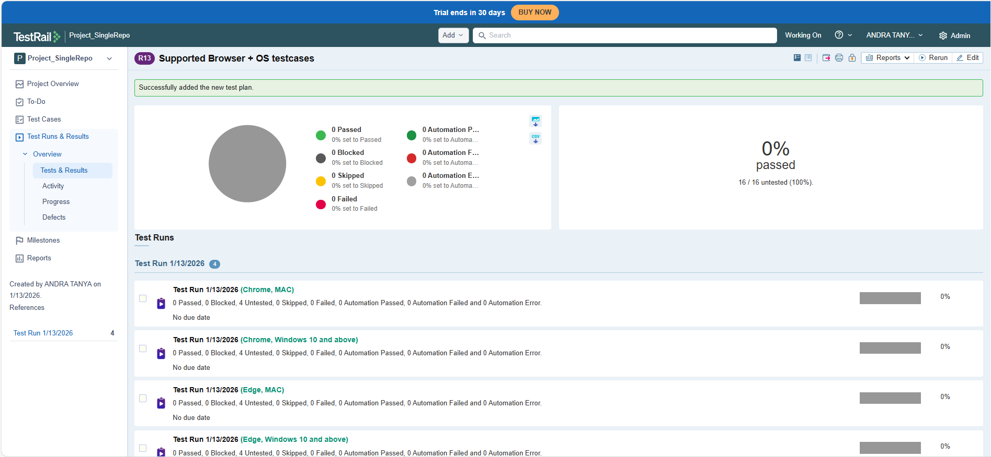

TestRail Sections and Subsections:

Sections and Subsections are simply for grouping and easy management of test cases available for time saving and clear purpose understanding.

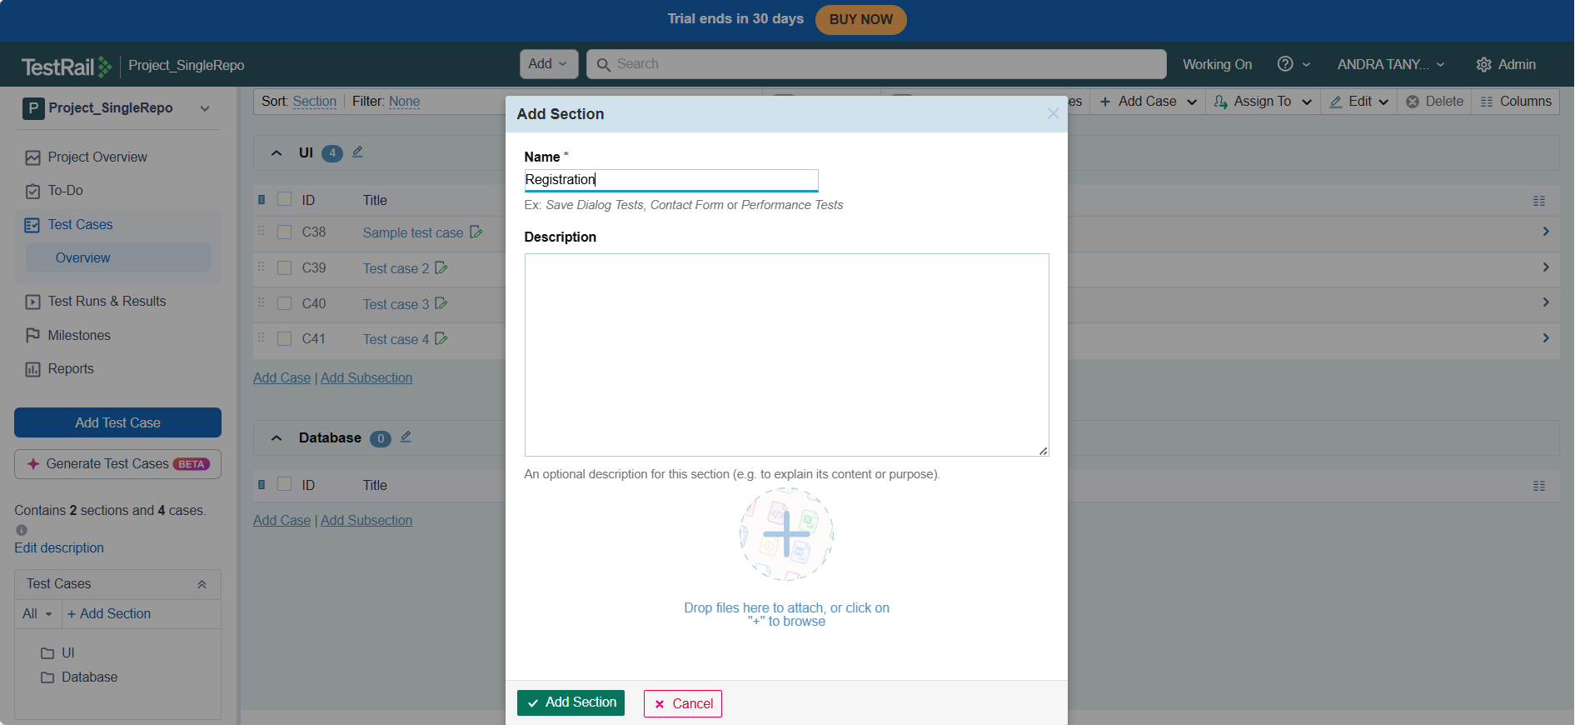

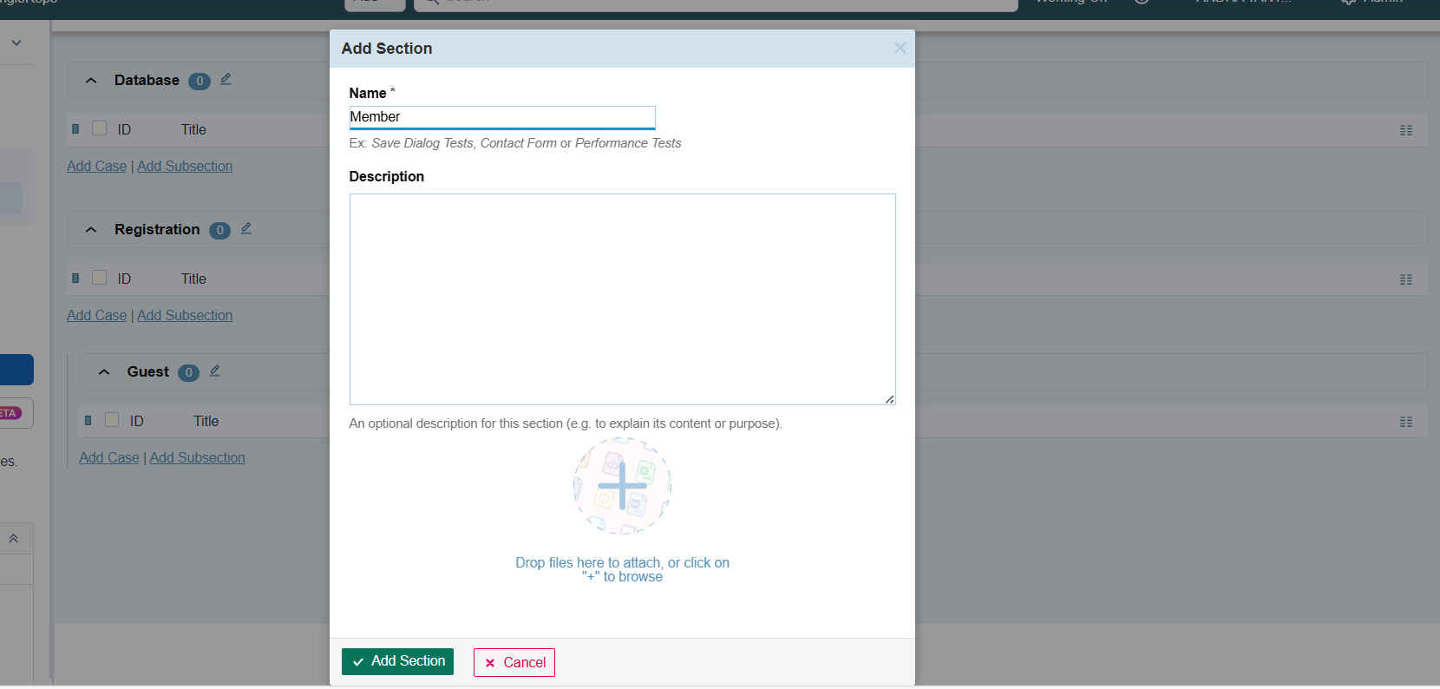

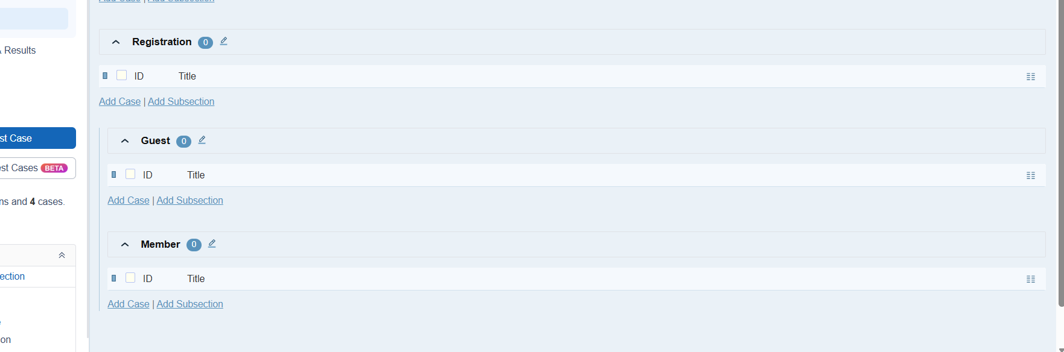

Milestone in TestRail:

Any important releases that we do as part of completion of features is considered as Milestone say Release 1, Release 2 … It contains Test Runs etc.,

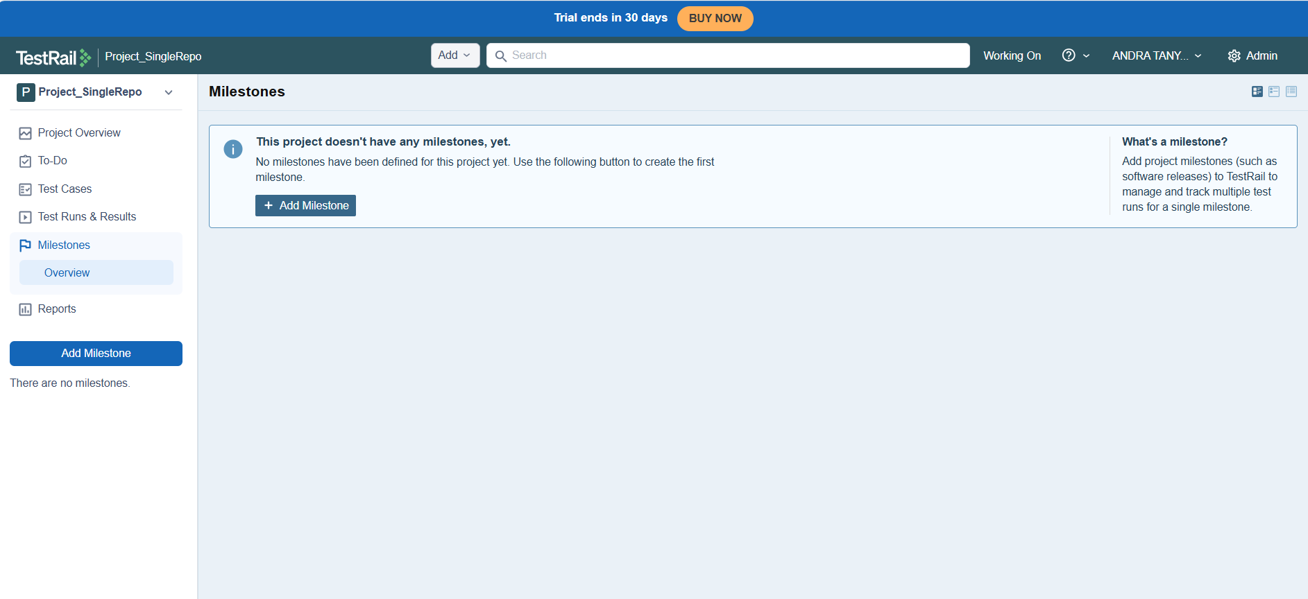

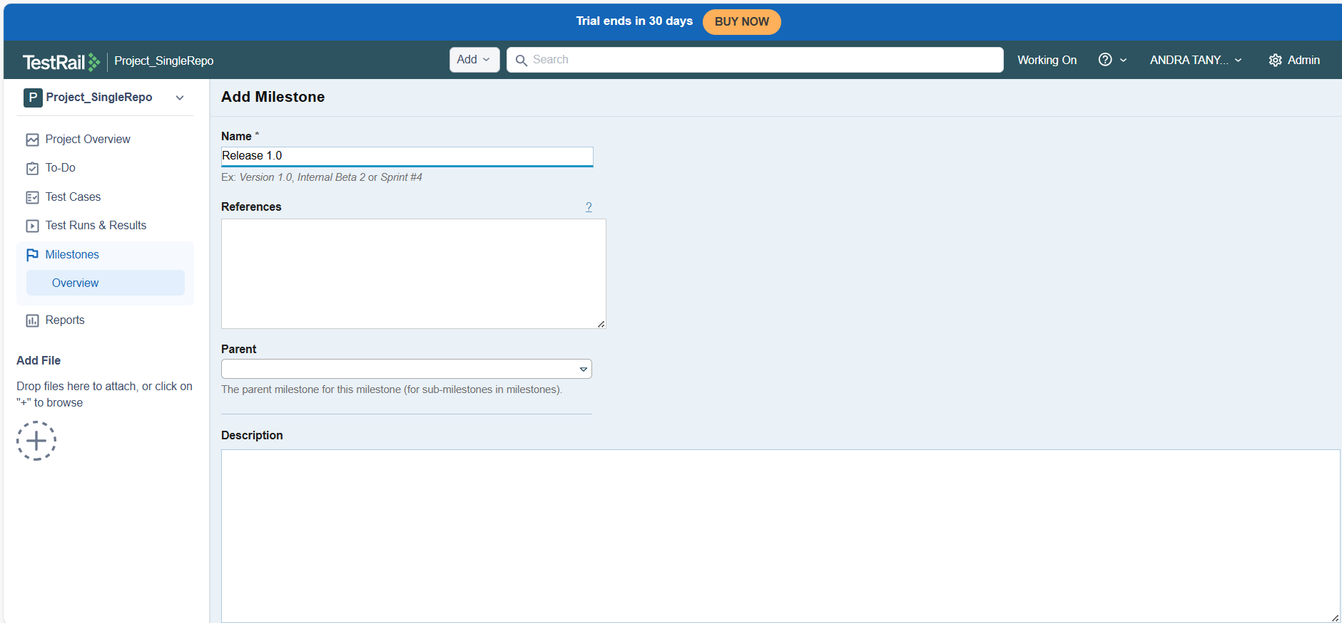

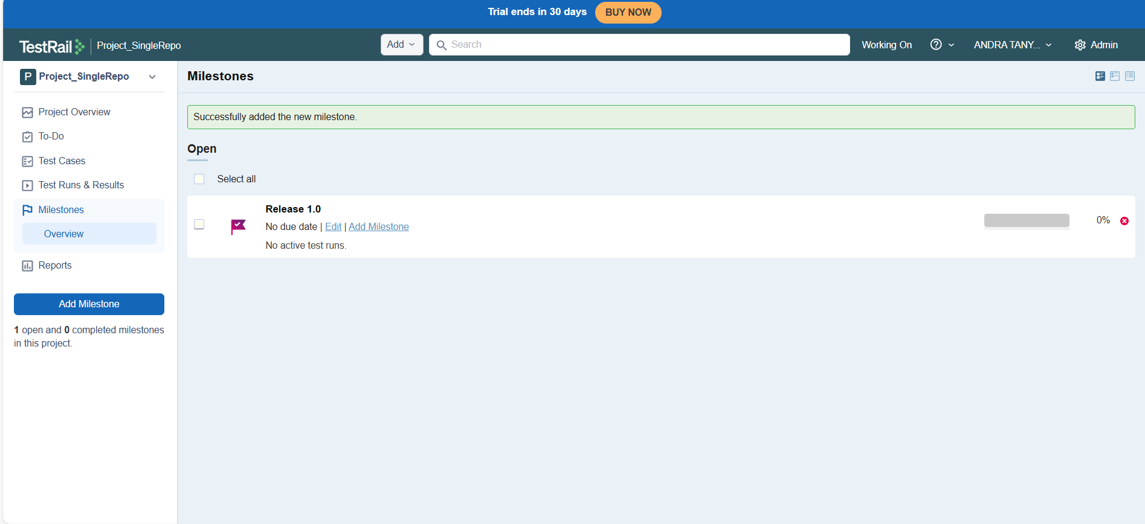
TestRuns in TestRail:
- I created a new test run in TestRail by navigating to the Test Runs & Results section of the project and selecting the option to add a test run. While creating the test run, I provided a meaningful name to identify the execution cycle and linked it to the relevant milestone (Release 1.0) to ensure proper traceability with the release version.
- During test run creation, I assigned the test run to a specific user to clearly define ownership and responsibility for execution. I also reviewed optional fields such as references, start date, and end date to understand how scheduling and external ticket linking can be managed within a test run.
- I selected the option to include specific test cases instead of including all available test cases. This allowed me to control the scope of testing for the run and ensured that only relevant test cases were executed for the given scenario.
- From the test case repository, I manually selected test cases under the UI section, including multiple individual test cases. This helped me understand how TestRail organizes test cases hierarchically and how selective inclusion works when preparing a focused test execution.
- After successfully creating the test run, I verified that all selected test cases were correctly added to the run and automatically assigned to the chosen user. The test run dashboard displayed the execution summary, including counts for untested, passed, failed, blocked, and skipped statuses.
- I reviewed the test run results overview to understand how execution progress is visually represented using charts and status indicators. All included test cases were initially marked as Untested, indicating readiness for execution.
- This practical exercise helped me gain hands-on experience with planning, creating, and managing test runs in TestRail, as well as understanding how test cases are organized, assigned, and tracked throughout the test execution lifecycle.

